VENUS, EARTH, and MARS

Most people, when they think of a “planet”, imagine a large roundish body with rocky surface and an atmosphere, just the kind that cool science fiction stories are written about. Forgetting Pluto for a moment (which has too many issues to deal with here), only Venus, Earth, and Mars share these characteristics as planets in our solar system.

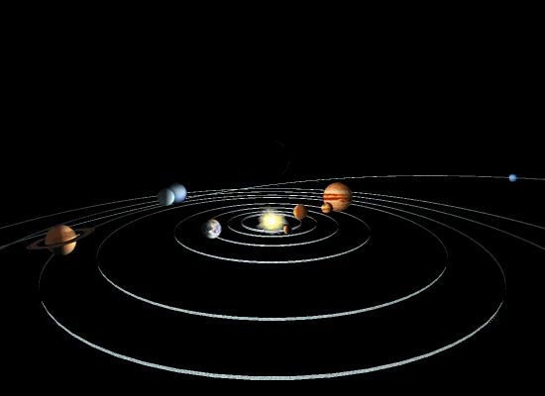
When astronomers think about planets, they generally divide them into two distinctive groups, the inner or “terrestrial” planets (Mercury, Venus, Earth, and Mars) and the outer or “jovian” planets (Jupiter, Saturn, Uranus, and Neptune). Pluto is a bit of an outlier and generally considered a KBO or Kuiper Belt Object or TNO (Trans Neptunian Object), referring to its probable origins outside the orbit of Neptune in a region where comets are thought to form. The inner planets all reside within about 250 million km from the sun. They are relatively small in size with radii ranging from 2440km for Mercury to 6378km for Earth and are generally slow rotators as planets go. They have rocky (or silicate based) surfaces that you could land on or walk on with the proper space suit gear. They also have dense inner cores composed primarily of heavy elements like iron and nickel, and, except for Mercury, they have substantial atmospheres containing clouds, water vapor, carbon dioxide, and other gases. Contrast this with the outer planets. The outer planets are, well, in the outer part of the solar system with orbital distances of greater than 750 million km. They are much larger than their inner planet cousins with radii ranging from between four and 11 times that of Earth and are composed primarily of very light gasses dominated by Hydrogen (H2) and Helium (He) with rich mixtures of a variety of hydrocarbon (like CH4, C2H6, and C2H2) and nitriles (Like NH3 and C2N2) species. They are huge balls of gas and condensed gasses (clouds) that rotate quite fast for their large size (9.5 hours for Jupiter to 17.24 hours for Uranus) – driving the fastest winds in the solar system. If you were to try to land on one of these gas giants, you would only sink through denser and denser layers of gas until you were crushed by the atmospheric pressure. In addition, they all have complex ring systems, a relatively large number of moons due primarily to their larger gravitational fields and large, global magnetic fields.

Focusing now on just on the Earth and its closest neighbors, we can compare just the three terrestrial planets, Venus, Earth, and Mars, and we find that although they have many things in common as previously stated, they are also worlds apart in many equally important respects.

One way that these three planets are very different is in their magnetic fields and their interactions with the solar wind. These differences are important to understand because they shed light on the processes that define our Earth’s near space environment and may give some clues as to how our Earth will evolve over time.

VENUS
Because Venus formed at the same time as the Earth, in the same general region of the solar system, and is very similar in both size (R(Venus) = 6052km vs R(Earth) = 6378 km) and density (Venus = 5.52 vs Earth = 5.24 g/cm³), it is believed that Venus has an internal structure quite similar to the Earth’s. Supporting data for internal models comes from gravity and magnetic field measurements from Venera, Pioneer Venus and Magellan spacecraft. It is believed that Venus formed a differentiated core with the heaviest elements such as iron sinking to the middle of the planet. It is not known if this core has yet solidified as much of the Earth’s core has. Regardless, in part because of its slow rotation (243 days) and its predicted lack of internal thermal convection, any liquid metallic portion of its core could not be rotating fast enough to generate a measurable global magnetic field. Limits on magnetic field strength from Magellan magnetometer data are 1.5e-5 times Earth’s field. Current theories of the formation and evolution of the terrestrial planets do support an Earth scale magnetic dipole (magnetic field) on Venus for perhaps the first billion years or so after formation. During that time, remnant thermal energy from the heat of creation probably drove the Venusian dynamo. After this heat was fully dissipated, there appear to have been no other internal processes with which to generate the convective motion needed to support a global field.

However, spacecraft observations do confirm the existence of an induced magnetosphere where the solar wind interacts directly with the planet’s ionosphere ions and electrons. Though no Earth like magnetotail or trapped radiation belts have been detected, the Venusian field possesses a number of similar attributes to a traditional dynamo generated field. These include:
- an ionopause where the solar wind pressure is just balanced by the ionosphere thermal energy. During periods of high solar activity, the ionopause boundary can dip to within 250km of the surface.
- a bow shock whos radius from the planet changes significantly as a function of solar activity, formed up stream in the solar direction.
- A magnetosheath or ionosheath inside the bowshock region
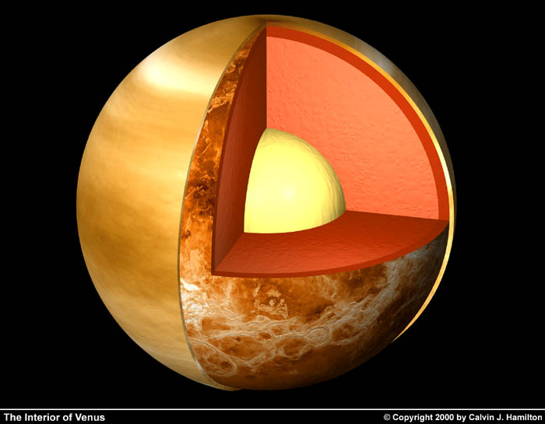

EARTH
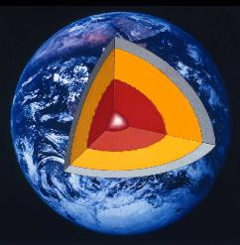
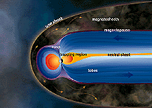
In 1600, William Gilbert hypothesized that the Earth was a giant magnet. He wasn’t far off! Deep within the Earth, exists a solid core composed mostly of iron about the size of the moon with temperatures on the order of 5,000K. This could easily be a convenient mechanism for generating the Earth’s observed, global magnetic field if it weren’t for the extremely high temperatures. Temperatures above a certain threshold (called the “Curie Point”) inhibit ferromagnetic materials from generating a magnetic field. The curie point for iron is about 1000K. So what’s generating the Earth’s magnetic field??? The answer lies in the liquid, metalic outer core of the Earth. Temperature differences between the Earth’s mantle and much hotter inner, solid core cause the fluid outer core material (primarily iron and nickel) to convect much like a pot of boiling water will stir because the surface of the water is cooler than the bottom of the pan. This, movement of charged material combined with the Coriolis effect caused by the differential rotation of the outer core with respect to the mantle is thought to generate currents which in turn generate the Earth’s magnetic field or “magnetosphere”. Since the core, outer core, and mantle are not rigidly connected, they do not have to spin at the same rate or in the same plane and the Earth’s magnetic field is, in fact, tilted 11 degrees to its geometric axis of rotation. The specific solutions to why or how this happens are still being studied.

In the absence of other forces, the Earth’s magnetosphere would look very similar to the traditional bar magnet / iron filing experiment where iron filings line up along symmetric magnetic field lines. However, in the presence of the solar wind, the Earth’s magnetosphere is compressed on the sunward side and hugely elongated on the anti-solar, or night side, producing a “geotail” that extends over 300,000 km (about the distance of the moon’s orbit) away from Earth. A bow shock where solar wind and magnetic field strength just balance, extending many Earth radii toward the sun represents the boundary between solar wind dominated space and magnetosphere dominated space. Within the magnetosphere, ions and electrons (charged particles) rotate around and are accelerated along magnetic field lines – giving them a sort of spiral trajectory. In addition, these charged particles gradually shift from field line to field line creating an electric current that encircles the Earth, called the “ring current”.

You can find out more about Venus, Earth, and Mars at:
http://nssdc.gsfc.nasa.gov

